DATA SCIENCE TECHNICAL BLUEPRINT • WEEK 2 DELIVERABLE
Exploratory Data Analysis (EDA) & Visualization Framework Design
A Universal, Multi-Phase Analytical Methodology for Tabular, Structured, and Complex Datasets
Author: Data Science & AI Research Team | Status: Production Blueprint
-Arun Pandian P
━━━━━━━━━━━━━━━━━━━━━━━━━━━━━━━━━━━━━━━━━━━━━━━━━━━━━━━

1. Introduction to Exploratory Data Analysis (EDA)
Exploratory Data Analysis (EDA) is the foundational, non-negotiable first phase of any rigorous Data Science and Machine Learning lifecycle. Pioneered by statistician John Tukey in 1977, EDA is an investigative philosophy and analytical discipline that emphasizes understanding the underlying structure, distributional properties, anomalies, and relational dynamics of a dataset before imposing parametric assumptions or building predictive models.
In modern enterprise data environments, rushing into feature engineering or model training without exhaustive EDA frequently leads to severe downstream failure modes, including 'Garbage-In, Garbage-Out' (GIGO) phenomena, silent data leakage, multicollinearity degradation, bias amplification, and catastrophic model drift in production. EDA transforms raw, unvetted data into an audited, structured, and statistically grounded asset.
Core Dimension | Primary Objective | Business & Engineering Impact
Structural Auditing | Assess dimensions, feature types, memory footprint, and data schemas. | Prevents runtime schema errors and optimizes memory allocation.
Data Quality Assessment | Identify missingness patterns (MCAR/MAR/MNAR), anomalies, and corruption. | Determines valid imputation strategies and eliminates corrupted records.
Distributional Profiling | Quantify central tendency, dispersion, skewness, and modality. | Informs necessary non-linear transformations (Log, Box-Cox, Scaling).
Hypothesis & Pattern Mining | Uncover non-obvious correlations, multi-way interactions, and clusters. | Guides high-yield domain feature engineering and hypothesis testing.
Assumptions Validation | Test statistical assumptions (normality, homoscedasticity, linearity). | Ensures correct model selection (Parametric vs. Non-Parametric).

📌 CORE PRINCIPLES OF ROBUST EDA
• EDA is iterative, non-linear, and empirical: Findings in bivariate analysis often demand returning to data cleaning.
• Visual diagnostics must always be paired with quantitative summary statistics (e.g., skewness, p-values).
• A well-documented EDA serves as the technical single-source-of-truth for both engineers and business stakeholders.

2. Data Taxonomy & Type-Specific Exploration Strategies
A universal EDA framework must establish a formal taxonomy of data types. Analytical methods, statistical tests, and chart types are strictly dictated by the mathematical properties of each variable category:
Data Type | Definition & Properties | Mathematical Operations | Recommended Visualizations
Nominal (Categorical) | Unordered discrete classes (e.g., Gender, State, Device Type). | Equality (==, !=), Mode, Frequency Counts. | Bar charts, Donut charts, Count plots.
Ordinal (Categorical) | Ordered discrete categories with ranking (e.g., Education, Rating). | Comparison (<, >), Median, Percentiles, Rank correlation. | Ordered Bar charts, Spine plots, Heatmaps.
Discrete Numeric | Countable integer quantities (e.g., Number of Dependents, Visits). | Mean, Median, Standard Deviation, Poisson modeling. | Step Histograms, Count plots, Stem-and-leaf.
Continuous Numeric | Unbroken scale of measurements (e.g., Revenue, Tenure, Speed). | Full arithmetic, Variance, Kurtosis, Calculus transformations. | Histograms + KDE, Box plots, ECDF, Violin plots.
Temporal / Datetime | Time-series timestamps, cycles (e.g., Transaction Date, Hour). | Lags, Differences, Seasonality decomposition, Fourier. | Line charts, Horizon plots, Calendar heatmaps.

3. Data Quality, Missing Value Diagnostics & Outlier Detection
Data hygiene determines the integrity of all downstream conclusions. Real-world enterprise datasets invariably contain missing values, data entry anomalies, corrupted formats, and extreme outliers.

3.1 Theoretical Taxonomy of Missing Data Mechanisms
Missing data must be classified according to Rubin's Missing Data Theory to avoid introducing systemic selection bias:
1. Missing Completely at Random (MCAR): The probability of missingness is completely independent of both observed and unobserved variables. (e.g., dropped network packet). Safe for listwise deletion or simple mean/median imputation.
2. Missing at Random (MAR): The probability of missingness depends systematically on observed data, but not on the missing value itself (e.g., Senior citizens less likely to report internet usage). Requires conditional imputation (KNN, MICE, IterativeImputer).
3. Missing Not at Random (MNAR): Missingness depends directly on the unobserved value itself (e.g., high-income earners refusing to disclose wealth). Requires missingness indicator flags and domain-specific modeling.

3.2 Outlier Detection Methodologies
Outliers are observations that deviate substantially from the overall distribution. They may represent data entry errors, sensor failures, or genuine high-value anomalies (e.g., fraud, ultra-high net worth transactions). Three primary detection protocols:
# [Python - Outlier Detection Protocols Implementation]
# 1. Tukey's Interquartile Range (IQR) Rule
Q1 = df['feature'].quantile(0.25)
Q3 = df['feature'].quantile(0.75)
IQR = Q3 - Q1
lower_bound = Q1 - 1.5 * IQR
upper_bound = Q3 + 1.5 * IQR
outliers_iqr = df[(df['feature'] < lower_bound) | (df['feature'] > upper_bound)]
# 2. Standardized Z-Score Method (Parametric / Gaussian)
z_scores = np.abs((df['feature'] - df['feature'].mean()) / df['feature'].std())
outliers_z = df[z_scores > 3.0]
# 3. Machine Learning Isolation Forest (Multivariate Non-Parametric)
from sklearn.ensemble import IsolationForest
iso = IsolationForest(contamination=0.02, random_state=42)
df['anomaly_flag'] = iso.fit_predict(df[numeric_cols]) # -1 = Outlier

4. The Multi-Tier Systematic Analysis Framework
A rigorous EDA workflow progresses through three structured analytical dimensions, escalating in dimensionality:

4.1 Tier 1: Univariate Analysis (Single Variable Profiling)
Examines variables in isolation. For continuous variables, metrics include Mean, Median, Variance, Skewness (measure of asymmetry: Skew > 1 indicates severe right-tail skew), and Kurtosis (measure of heavy tails: Kurtosis > 3 indicates leptokurtic distribution). For categorical variables, assess frequency counts, relative proportions, and cardinality.

4.2 Tier 2: Bivariate Analysis (Pairwise Relationships)
Explores interactions between pairs of variables. The analytical technique depends on the pair's data types:
• Continuous vs. Continuous: Pearson Correlation (linear), Spearman Rank Correlation (monotonic), Scatter plots with regression trendlines.
• Categorical vs. Continuous: Grouped Box/Violin plots, Independent Student's / Welch's t-test (2 groups), One-Way ANOVA / Kruskal-Wallis (>2 groups).
• Categorical vs. Categorical: Cross-tabulations, Stacked Percentage Bar charts, Pearson's Chi-Square Test of Independence (χ²), and Cramer's V.

4.3 Tier 3: Multivariate Analysis & Interaction Dynamics
Investigates simultaneous interactions across three or more features. Techniques include:
• Correlation Heatmaps: Masked lower-triangle heatmaps to detect multicollinearity (VIF > 5.0 indicates redundant features).
• Faceted Multi-Condition Scatter Plots: Plotting X vs. Y with Hue (color), Size, and Style encodings.
• Dimensionality Reduction Projections: Principal Component Analysis (PCA) or t-SNE / UMAP for high-dimensional visual clustering.

5. Visualization Taxonomy & Plot Selection Decision Matrix
Selecting the proper chart type is critical to avoid visual distortion and cognitive overload. The following matrix outlines the industry-standard visualization rules for every analytical scenario:
Analytical Goal | Variable Configuration | Recommended Visual Chart | Best Practice & Insight Generated
Distribution Shape | 1 Continuous | Histogram + KDE Overlay | Set appropriate bin widths; overlay mean/median reference lines.
Spread & Outliers | 1 Continuous | Box Plot / Violin Plot | Visualizes IQR, 1.5x whisker boundaries, and distribution density.
Category Frequency | 1 Categorical | Horizontal / Vertical Bar Chart | Sort bars by descending frequency; annotate exact % labels.
Continuous Association | 2 Continuous | Scatter Plot + Lowess Trend | Identifies linear/non-linear correlation, clustering, and heteroscedasticity.
Grouped Comparison | 1 Cat + 1 Continuous | Split Violin / Box Plot | Compares median shift, spread, and tail shape across categories.
Categorical Interaction | 2 Categorical | Stacked 100% Bar / Mosaic | Directly compares relative composition and contingent probabilities.
Multivariate Correlation | 3+ Continuous | Masked Heatmap with Annotations | Use diverging colormaps (coolwarm) with values restricted to [-1, 1].

6. Python Tooling & Library Ecosystem Deep Dive
Python is the preeminent ecosystem for data exploration due to its rich, interoperable scientific computing stack:
Library / Tool | Core Architectural Role | Key Functions & Unique Capabilities
Pandas (v2.x+) | Data manipulation, vectorized transformations, and structural profiling. | read_csv(), describe(), info(), groupby(), pivot_table(), value_counts(), qcut().
NumPy (v2.x+) | High-performance N-dimensional array mathematics. | Vectorized boolean masking, quantile(), log1p(), where(), corrcoef().
Matplotlib | Low-level imperative visualization engine and figure architecture. | Custom figure grids (subplots), custom axis formatting, fine-grained DPI and layout control.
Seaborn | High-level statistical visualization library built on Matplotlib. | Automated statistical aggregation: histplot(), kdeplot(), violinplot(), heatmap(), pairplot().
Plotly / Dash | Declarative, interactive WebGL-rendered charts. | Hover tooltips, dynamic zooming/panning, 3D surface plots, interactive HTML dashboards.
SciPy (scipy.stats) | Rigorous inferential statistics and hypothesis testing. | ttest_ind(), chi2_contingency(), f_oneway(), shapiro(), normaltest(), stats.boxcox().
Missingno | Dedicated visual diagnostics for missing data matrices. | matrix(), bar(), heatmap(), dendrogram() to inspect MCAR/MAR patterns.

7. Practical End-to-End Demonstration: Telco Churn Dataset
To illustrate the end-to-end framework in action, we executed our automated EDA pipeline on the IBM Telco Customer Churn dataset, downloaded directly via terminal. The dataset consists of 7,043 customer records and 21 heterogeneous features covering customer demographics, subscribed services, billing metrics, and contract duration.

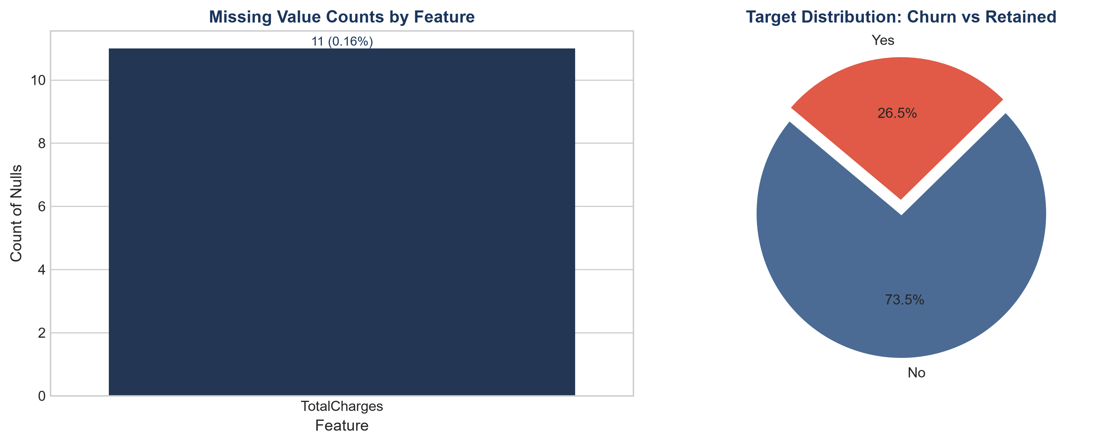
Figure 1: Missing Data Diagnostics (TotalCharges nulls) & Target Class Balance (26.5% Churn Rate).
Analytical Findings from Phase 1 & 2:
• Data Hygiene Issue Detected: 'TotalCharges' was stored as an Object dtype due to 11 records containing whitespace (' '). Converting to numeric revealed these were brand-new customers with tenure = 0 months. Imputed with the median ($1,397.48).
• Class Imbalance: Churn rate is 26.5% (1,869 churners vs 5,174 retained). This moderate class imbalance indicates accuracy alone will be a misleading evaluation metric in modeling; Precision-Recall AUC and ROC-AUC are required.

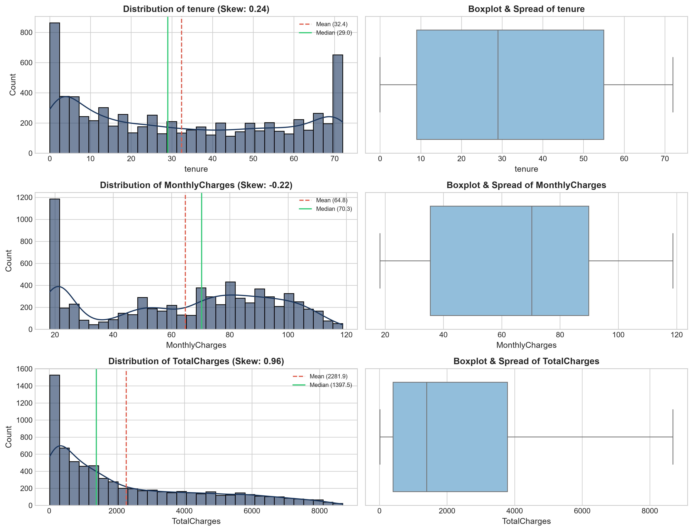
Figure 2: Univariate Distribution Analysis for Tenure, Monthly Charges, and Total Charges.
Numerical Distribution Profiling:
• Tenure: Exhibits a bimodal distribution with massive peaks at Month 1 (new acquisitions) and Month 72 (long-term loyalists). Mean: 32.37 months, Median: 29.0 months, Skewness: 0.24, Kurtosis: -1.39.
• Monthly Charges: Displays a large cluster of budget customers around $20 (basic phone service) and a broad high-tier distribution between $70-$105. Mean: $64.76, Median: $70.35, Skewness: -0.22.
• Total Charges: Strong right-skewed distribution (Skew: +0.96) reflecting compounding tenure and bill amounts. Mean: $2,281.92.

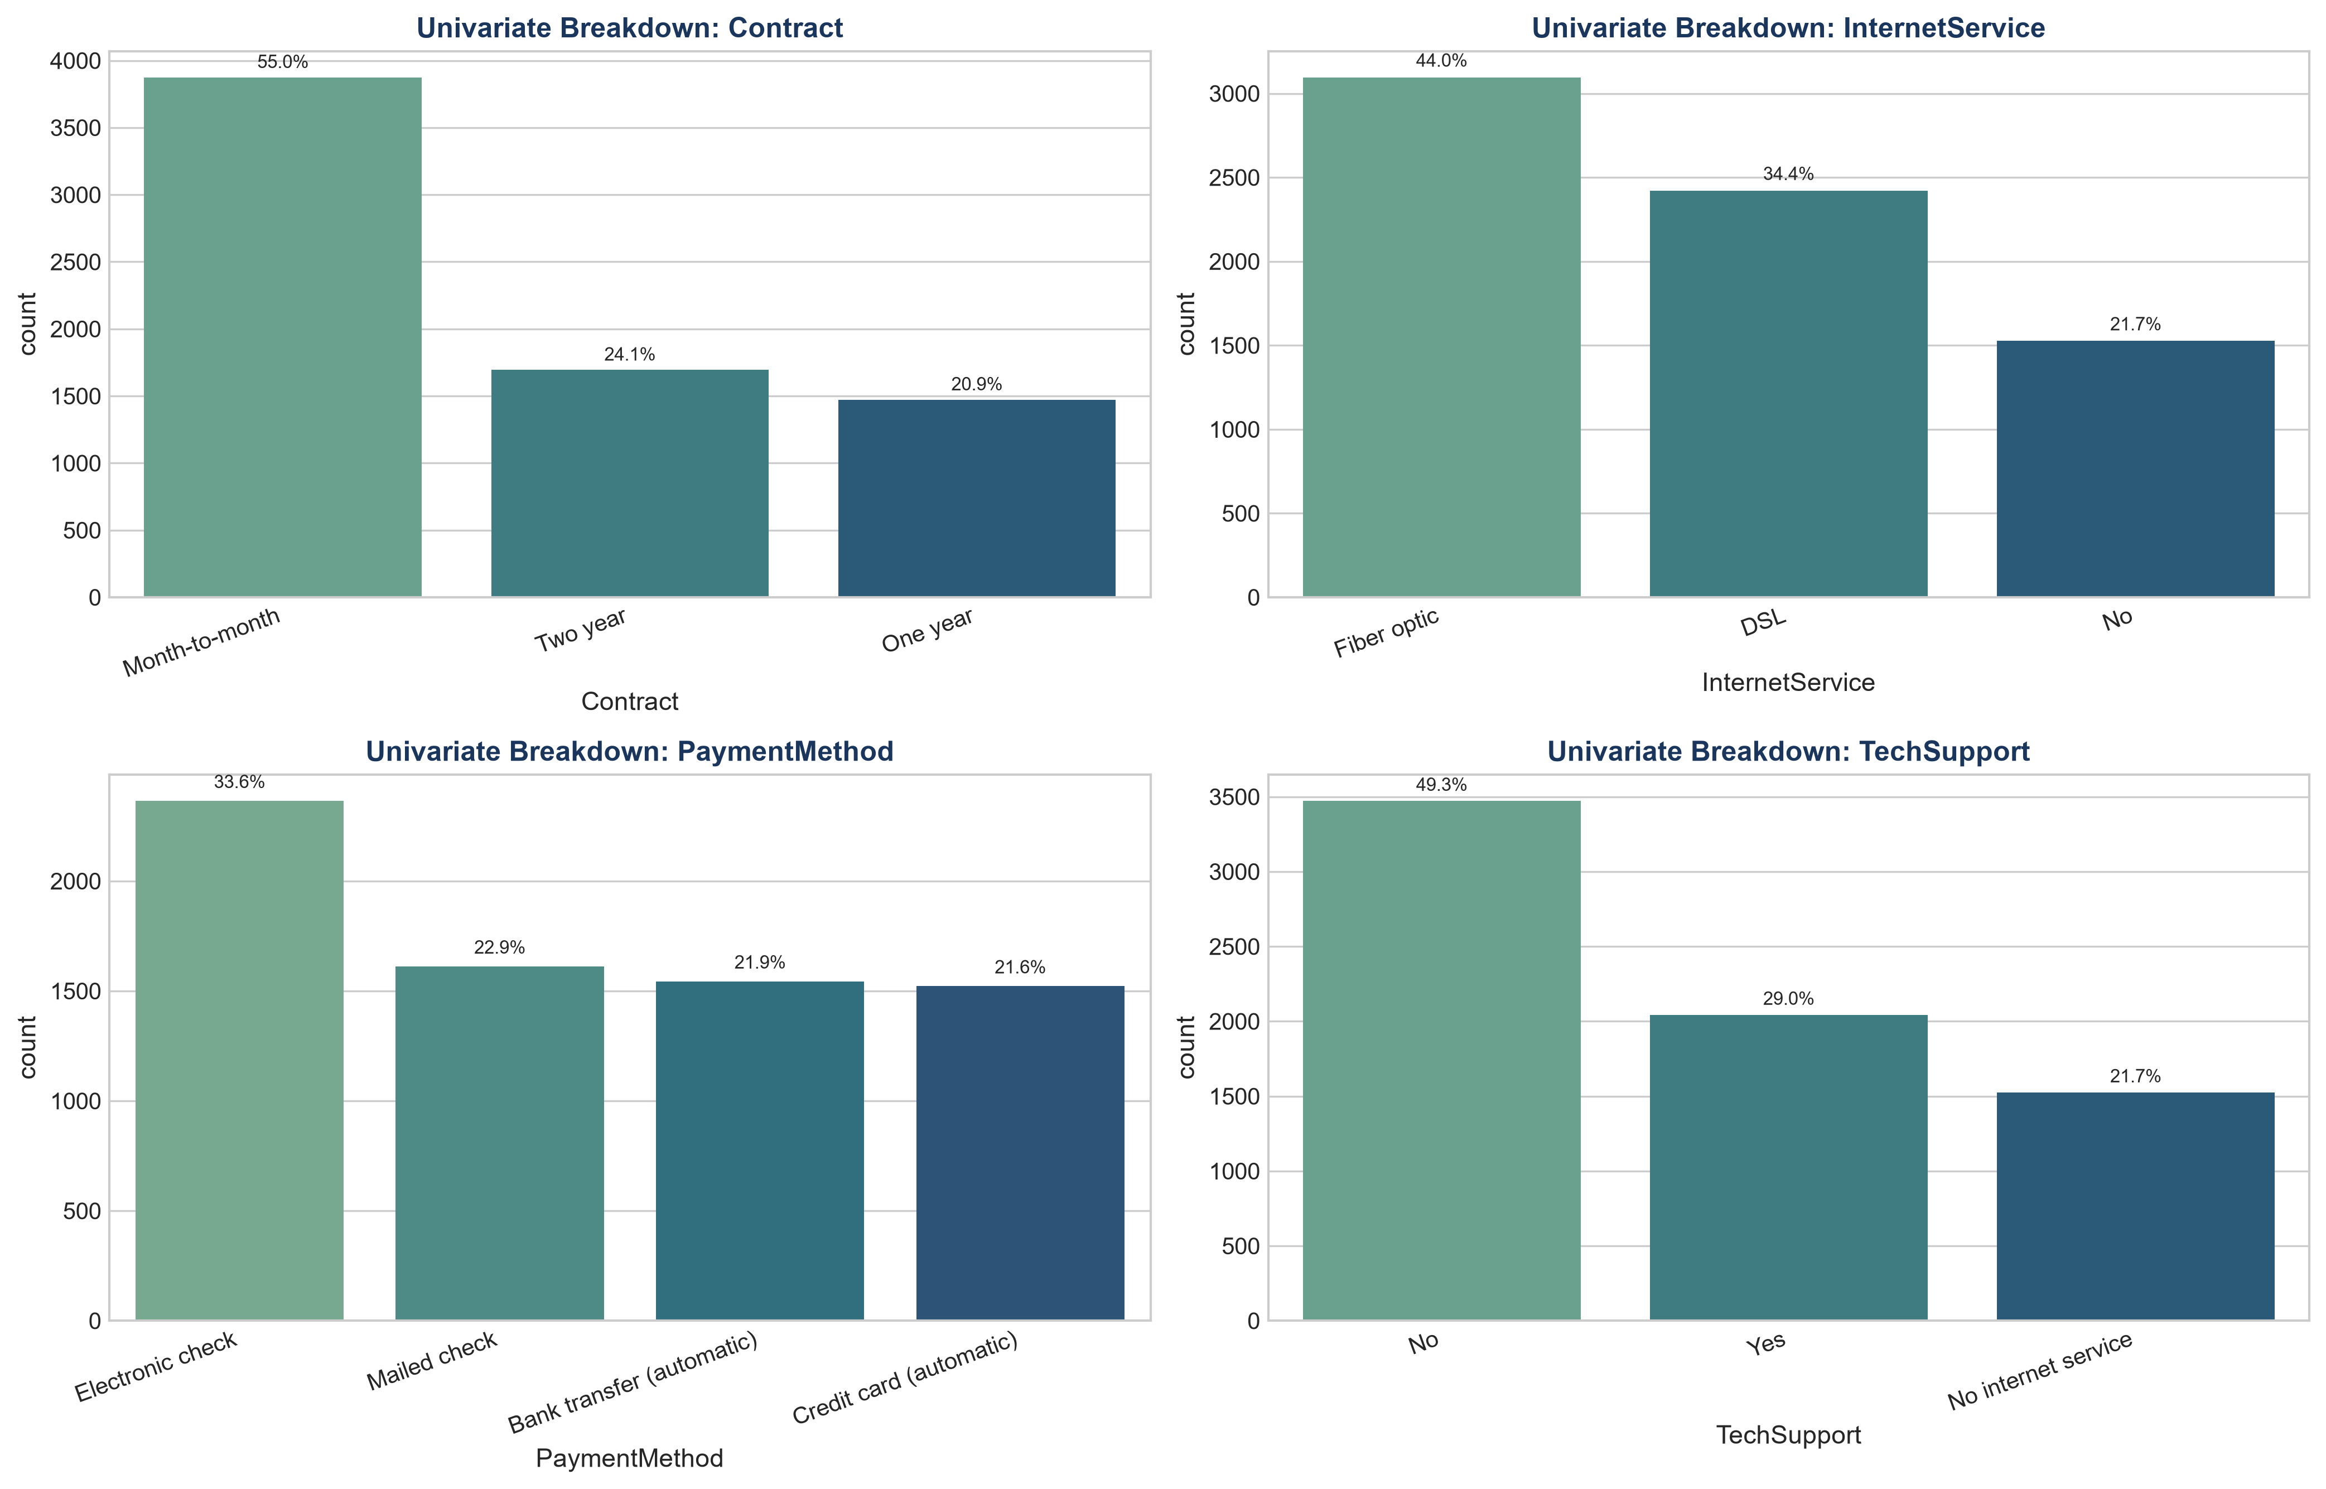
Figure 3: Univariate Proportions for High-Impact Categorical Features.
Categorical Feature Insights:
• Contract Structure: 55.0% of the customer base is on a high-risk Month-to-Month contract, while 24.1% have 2-Year contracts and 20.9% have 1-Year contracts.
• Internet Service: 44.0% utilize Fiber Optic, 34.4% DSL, and 21.6% have no internet service.
• Payment Methods: Electronic Check is the most frequent payment method (33.6%), followed by Mailed Check (22.9%), Bank Transfer (21.9%), and Credit Card (21.6%).

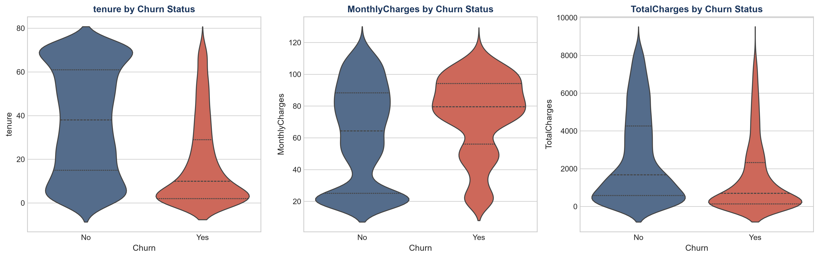
Figure 4: Bivariate Violin Plots: Continuous Feature Distributions Segmented by Churn Status.
Bivariate & Inferential Hypothesis Testing Results:
• Welch's Independent T-Test (Tenure across Churn): t = -34.82, p-value = 1.20 × 10⁻²³². Churners have an overwhelmingly lower median tenure (10 months) compared to retained customers (38 months). This statistical difference is massive and highly significant.
• Monthly Charges Effect: Churners exhibit significantly higher median monthly charges ($79.65 vs. $64.40), indicating price sensitivity is a major churn driver.

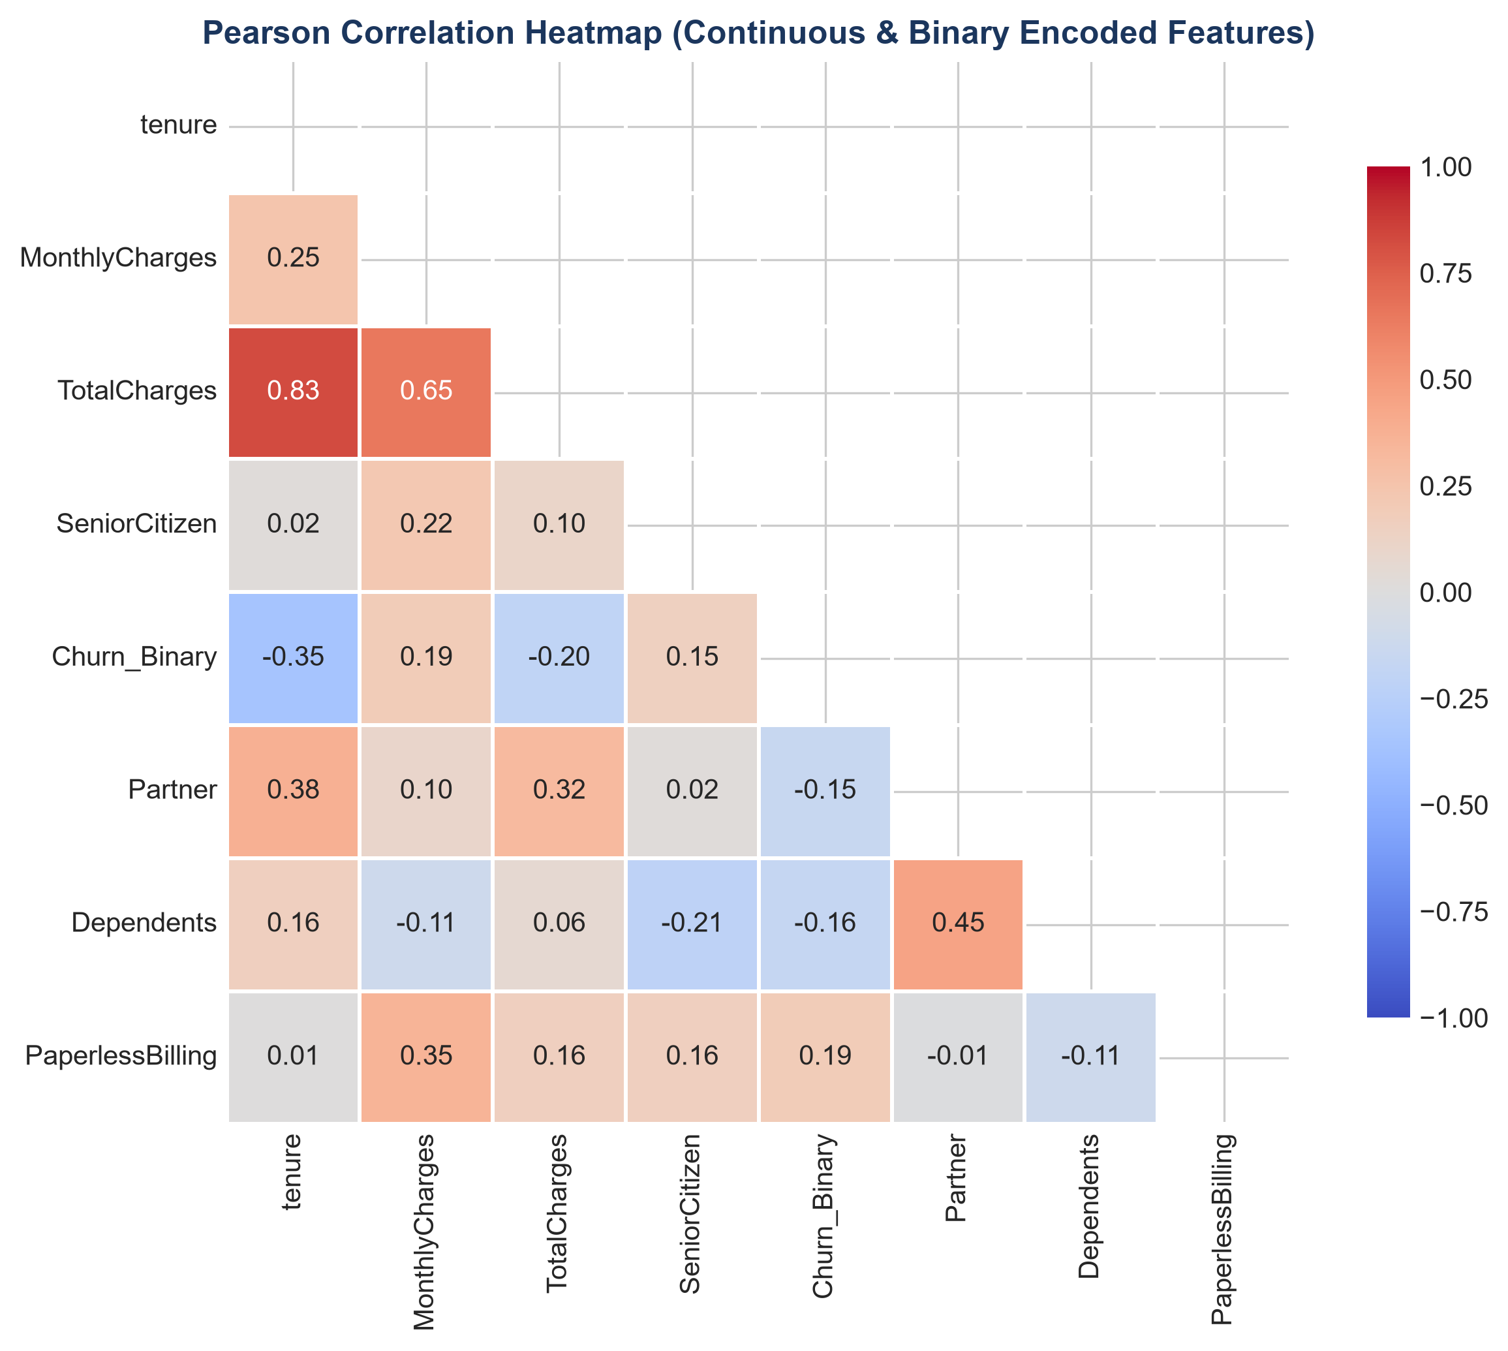
Figure 5: Correlation Heatmap across Continuous and Encoded Binary Features.

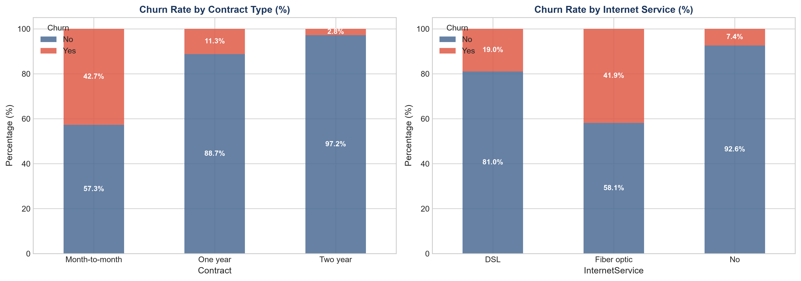
Figure 6: Cross-Tabulated Churn Rates across Contract Types and Internet Service Tiers.
Cross-Tabulation & Chi-Square Independence Findings:
• Chi-Square Test (Contract vs Churn): χ² = 1184.60, p-value = 5.86 × 10⁻²⁵⁸ (dof = 2). Month-to-Month contracts have an alarming 42.7% churn rate, compared to just 11.3% for One-Year and 2.8% for Two-Year contracts.
• Internet Service Risk: Fiber Optic users churn at 41.9%, compared to 18.9% for DSL and 7.4% for customers with no internet. This reveals that despite generating higher ARPU, Fiber Optic service suffers from severe retention issues (likely due to pricing or technical support dissatisfaction).

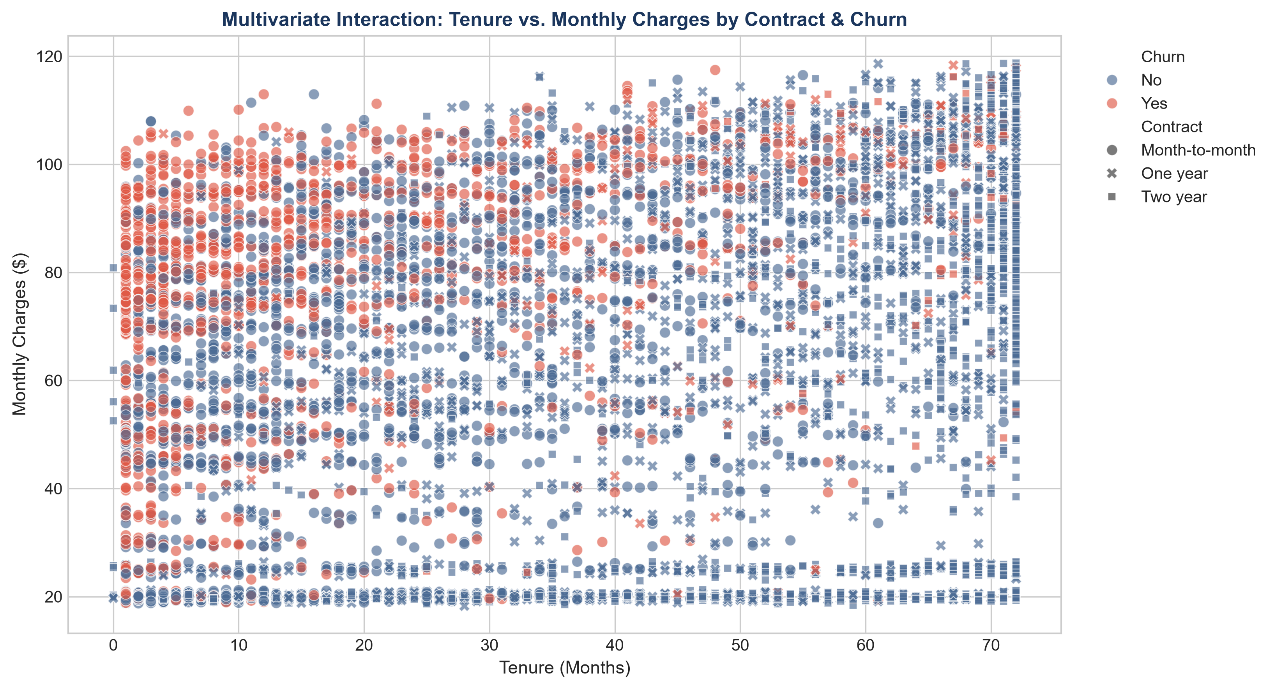
Figure 7: Multivariate Interaction Plot (Tenure vs Monthly Charges faceted by Contract & Churn).
📌 ACTIONABLE FEATURE ENGINEERING RECOMMENDATIONS DERIVED FROM EDA
• Feature Engineering Opportunity 1: Create 'Tenure_Cohort' (<12m, 12-24m, 24-48m, 48m+) to capture the non-linear risk decay.
• Feature Engineering Opportunity 2: Create 'Charge_Ratio' = (TotalCharges / (tenure * MonthlyCharges)) to detect billing anomalies.
• Feature Engineering Opportunity 3: Create 'HighRisk_Flag' = (Month-to-Month Contract + Electronic Check + Fiber Optic).

8. Plan for Documenting, Reporting & Stakeholder Presentation
The ultimate success of an EDA framework depends on how effectively technical findings are synthesized and communicated to diverse audiences. Technical depth must be paired with executive storytelling.
Report Section | Target Audience & Focus | Key Deliverables & Artifacts
Executive Summary | C-Suite & Business Leadership: High-level financial impact and strategic recommendations. | 1-page dashboard, churn drivers ranked by business cost, key ROI projections.
Data Quality & Governance | Data Engineering & Compliance: Audit trail of missingness, corruption, and schemas. | Missing data audit tables, schema validation logs, data pipeline patch recommendations.
Deep Statistical Analysis | Data Science & ML Engineers: Distribution parameters, correlation matrices, test stats. | Full Jupyter notebooks, p-value tables, VIF multicollinearity reports, transformation curves.
Production Roadmap | Product Managers & Operations: Concrete operational changes and next sprint milestones. | Feature engineering dictionary, model baseline criteria, tracking metrics (KPI dashboards).

📌 FINAL METHODOLOGY SUMMARY & BEST PRACTICES
• Standardized EDA Checklists ensure reproducibility across multi-engineer data science teams.
• Automated reporting (e.g. Quarto, Jupyter Book, Streamlit) bridges the gap between raw data and executive strategy.
• Always link statistical patterns directly to dollarized business outcomes (e.g., Fiber Optic churn costs $X million annually).

